(4.1) Three Phase Transformer

Three phase transformers are more economical for supplying large loads and large power distribution. Even though most of the utilization equipments are connected by the single phase transformers, these are not preferred for large power distribution in the aspect of economy.

The three phase power is used in almost all fields of electrical power system such as power generation,
transmission and distribution sectors, also all the industrial sectors are supplied or connected with three phase system. Therefore, to step-up (or increase) or step-down (or decrease) the voltages in the three phase systems, three phase transformers are used. As compared with
the single phase transformer, there are numerous advantages with 3 phase transformer such as smaller and lighter to construct for the same power handling capacity, better operating characteristics, etc.

Three Phase Transformer

Three phase transformers are used to step-up or step-down the high voltages in various stages of power transmission system.

The power generated at various generating stations is in three phase nature and the voltages are in the range of 13.2KV or 22KV.

In order to reduce the power loss to the distribution end, the power is transmitted at somewhat higher voltages like 132 or 400KV.

Hence, for transmission of the power at higher voltages, three phase step-up transformer is used to increase the voltage. Also at the end of the transmission or distribution, these high voltages are step-down to levels of 6600, 400, 230 volts, etc.

A three phase transformer can be built in two ways:-

I. A bank of three single phase transformers

II. single unit of three phase transformer.

The former one is built by suitably connecting three single phase transformers having same ratings and operating characteristics. In this case if the fault occurs in any one of the transformers, the system still retained at reduced capacity by other two transformers with

open delta connection. Hence, continuity of the supply is maintained by this type of connection. These are used in mines because easier to transport individual single phase transformers.

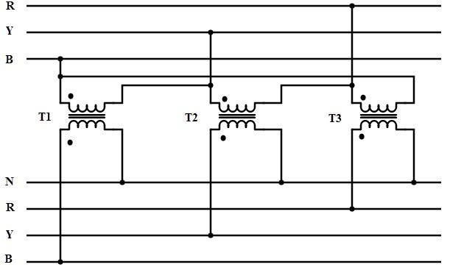

Instead of using three single phase transformers, a three phase bank can be constructed with a single three phase transformer consisting of six windings on a common multi-legged core. Due to this single unit, weight as well as the cost is reduced as compared to three units of
the same rating and also windings, the amount of iron in the core and insulation materials are saved. Space required to install a single unit is less compared with three unit bank. But the only disadvantage with single unit three phase transformer is if the fault occurs in any
one of the phase, then entire unit must be removed from the service.

Construction-

A three phase transformer is used to transfer a large amount of
power. The three phase transformer is required to step-up and step-down the voltages at various stages of a power system network.

The three phase transformer is constructed in two ways:-

1. Three separate single phase transformer is suitably connected for three phase operation.
2. A single three-phase transformer in which the cores and windings for all the three phases are merged into a single structure.

The three single-phase transformer can be used as a three-phase transformer when their primary and secondary winding are connected to each other. The three phase transformer supply has many advantages as compared to three single phase units like it requires very less space and also very lighter smaller and cheaper in size.

The three phase transformer is mainly classified into two types:-

1.The core type transformer

2.The shell type transformer.

Core Type Construction

In core type three phase transformer, core is made up of three limbs or
legs and two yokes. The magnetic path is formed between these yokes and limbs. On each limb both primary and secondary windings are wounded concentrically.

Circular cylindrical coils are used as the windings for this type of transformer. The primary and secondary windings of one phase are wounded on one leg. Under balanced condition, the magnetic flux in each phase of the leg adds up
to zero. Therefore, under normal conditions, no return leg is needed. But in case of unbalanced
loads, high circulating current flows and hence it may be best to use three single phase transformers.

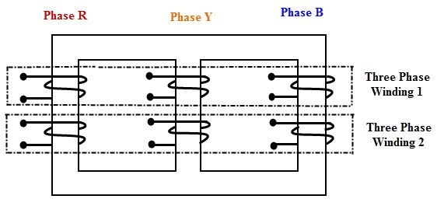

Shell Type Construction

In shell type, three phases are more independent because each phase
has independent magnetic circuit compared with core type transformer. The construction is similar to the single phase shell type transformer built on top of another. The magnetic circuits of this type of transformer are in parallel. Due to this, the saturation effects in common magnetic paths are neglected. However, shell type constructed transformers are rarely used in practice.

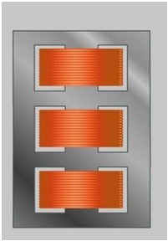

Working of Three Phase Transformers

Consider the below figure in which the primary of the transformer is connected in star fashion on the cores. For simplicity, only primary winding is shown in the figure which is connected across the three phase AC supply. The three cores are arranged at an angle of 120 degrees to each other. The empty leg of each core is combined in such that they form center leg.

working of a transformer:-

When the primary is excited with the three phase supply source, the currents IR, IY and IB are starts flowing through individual phase windings. These currents produce the magnetic fluxes ΦR, ΦY
and ΦB in the respective cores. Since the center leg is common for all the cores, the sum of all three
fluxes are carried by it. In three phase system, at any instant the vector sum of all the currents is zero.
In turn, at the instant the sum of all the fluxes is same. Hence, the center leg doesn’t carry any flux at any instant. So even if the center leg is removed it makes no difference in other conditions of the transformer.

Likewise, in three phase system where any two conductors acts as return for the current in third conductor, any two legs acts as a return path of the flux for the third leg if the center leg is removed in case of three phase transformer. Therefore, while designing the three phase transformer, this principle is used.

These fluxes induce the secondary EMFs in respective phase such that they maintain their phase angle between them. These EMFs drives the currents in the secondary and hence to the load. Depends on the type of connection used and number of turns on each phase, the voltage induced will be varied for obtaining step-up or step-down of voltages.

Advantages of Three Phase Transformers:-

Being prewired and ready to install, these can be easier to install.
To provide the same KVA, the core material required is very less compared to a bank of three single phase transformers.
It is lighter and smaller.
It requires less space to install.
Higher efficiency
Low cost compared with three units of single phase transformers.
Transportation is easy and also transportation cost is less.
Bus bar structure and switchgear installation for single three phase unit is simpler.
Only three terminals are required to be brought out in case of a three phase transformer compared to six terminals from three single phase transformers.

Disadvantages of Three Phase Transformers:-

In case of fault or loss of one phase results to the complete unit shut down. This is because in three phase transformer, a common core is shared for all three units. If one unit is defective, the core of this defective unit would immediately saturate because the absence of an opposing magnetic field. This causes the greater escape of magnetic flux to the metal enclosures from the core. This further raises the heating of the metallic parts and in some cases this heat would enough to cause to fires. Therefore, a three phase transformer (or entire unit) must be shut down if any one phase is defective.

Cost of repair is more for three phase transformer.
To restore the service, spare unit cost is more compared with one single transformer spare unit.
When these are self cooled, the capacity of the transformer is reduced.

Components of a Transformer:-

Basic Parts of a Transformer

These are the basic components of a transformer.

1. Laminated core
2. Windings
3. Insulating materials
4. Transformer oil
5. Tap changer
6. Oil Conservator
7. Breather
8. Cooling tubes
9. Buchholz Relay
10.Explosion vent

1. Core:-

The core of the transformer is used to support the windings. It is made of soft iron to reduce eddy current loss and Hysteresis loss, and provides low reluctance path to the flow of magnetic flux. The diameter of a transformer’s core is directly proportional to copper loss and inversely proportional to iron loss.

2. Windings:-

Windings consist of several copper coil turns bundled together, each bundle connected to form a complete winding. Windings can be based either on the input-output supply or on the voltage range. Windings that are based on supply are classified into primary and secondary windings, meaning the windings to which the input and output voltage is applied respectively. On the other hand, windings based on voltage range can be classified into high voltage and low voltage windings.

3. Insulating materials:-

Insulating materials like papers and card boards are used to isolate primary and secondary windings from each other as well as the transformer core. These windings are made of copper due to high conductivity and ductility. High conductivity minimizes the amount of copper needed and minimizes losses. Moreover, high ductility results in easy bending of conductors into tight winding around the core that also minimizes the amount of copper and volume of winding.
4. Transformer oil:-

The transformer oil insulates as well as cools the core and coil assembly. The core and windings of the transformer must be completely immersed in the oil that normally contains hydrocarbon mineral oils.

5. Conservator:-

The conservator is an airtight metallic cylindrical drum fitted above the transformer that conserves the transformer oil. It is vented at the top and is filled only half with the oil to allow expansion and contraction during temperature variations. However the main tank of the transformer with which the conservator is connected is completely filled with the oil through a pipeline.

6. Breather:-

The breather is a cylindrical container filled with silica gel, which is used to keep the air that enters the tank moisture-free. This is because the insulating oil when reacts with moisture can affect the insulation and cause internal faults, which is why it is a must to keep the air free from moisture. In the breather, when the air passes through the silica gel, the moisture contents are absorbed by the silica crystals.

7. Tap changer:-

To balance voltage variations within the transformer, tap changers are used. There are two types of tap changers – on load and off load. In on load tap changers, tapping can be changed without isolating transformer from the supply, while in off load, the transformer needs to be disconnected from the supply.

8. Cooling tubes:-

As the name suggests, cooling tubes are used to cool the transformer oil. The circulation of oil within the transformer may be natural or forced. In the case of natural circulation, when the oil temperature rises, the hot oil naturally moves to the top and cold oil moves down, while in case of forced circulation, an eternal pump is used.

9. Buchholz Relay:-

Placed over the connecting pipe that runs from the main tank to conservator tank the Buchholz Relay senses the faults occurring within the transformer. It operates by the gases emitted due to decomposition of transformer oil during internal faults. Thus, this device is used to sense and in turn protect the transformer from internal faults.

10. Explosion vent:-

The boiling hot oil from the transformer is expelled during internal faults through the explosion vent to avoid explosion of the transformer. This is generally placed above the level of the conservatory tank.
Tap changer:-

Tap changers exist in two primary types:-

1. Off load tap changers (NLTC) which must be de-energized before the turn ratio is adjusted.

2. On load tap changers (OLTC) which may adjust their turn ratio during operation.

1. The function of a tap changer is to regulate the transformer output voltage. The number of turns on a secondary winding dictates the transformer output voltage, therefor, if we
decrease or increase the amount of secondary windings within the circuit, we can regulate
the transformer output voltage.

2. The tap changer connects more windings to the circuit, or less. If we increase the number of windings, we increase the output voltage. This occurs because more conductor (windings) is exposed to the magnetic field and thus more voltage is induced. If we reduce the number of turns on a winding, then the amount of voltage induced is also reduced. This effect is understood if you consider that the voltage ratio (input to output voltage ratio) is
directly proportional to the turns ratio (number of primary windings to number of secondary windings).

(4.2) Three Phase Transformer Connections

As discussed above, either by a single three phase transformer or by three single phase transformers combination, three phase transformations can be carried out. The way of connecting the windings for three phase transformation is same whether the three windings of a three phase transformer or three windings of three single phase transformers are used. The primary and secondary windings are connected in different ways, such as in delta or star or combination of these two. The voltage and current ratings of the three phase transformer is depends on suitable connection.

The most commonly used connections are:-

Star-delta
Delta-star
Delta-delta
Star-star
Star – Delta Connection:-

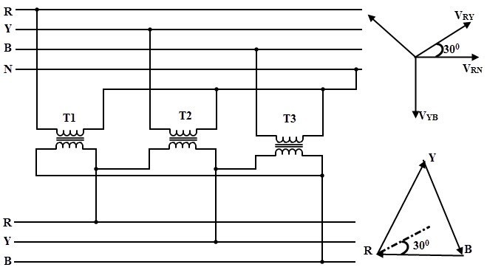

This type of connection is commonly used to step-down the voltages to a lower value in transmission end substations. Utility companies use this connection to reduce the voltage levels for distribution systems.

In this, the primary winding of the transformer is connected in star and secondary in delta connection.
The neutral point on the primary or high voltage side can be grounded which is
desirable in most of the cases.
The line voltage ratio between secondary and primary is 1/√3 times the transformation ratio of each transformer.
There exists 30 degrees phase difference between primary and secondary line
voltages.
Since the actual primary coil voltage is 58% of the primary line voltage, the insulation requirements for HV windings is reduced by using this winding.
In this connection balanced three phase voltage are obtained at the secondary or LV
side, even when the unbalanced currents are flowing the in the primary or HV side due to neutral wire. The neutral wire grounding also provides lightning surge protection.

Delta – Star Connection:-

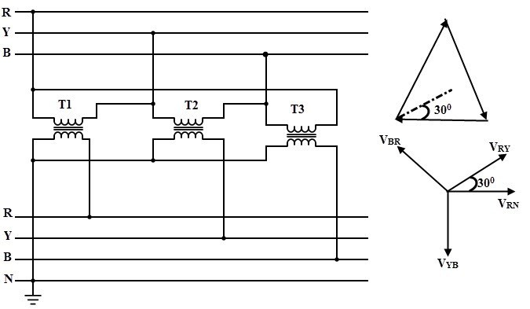

This connection is used to step-up the voltage level and is commonly employed in sending end or starting of high tension transmission system.

In this, the primary is connected in delta fashion and secondary in star fashion so that three phase 4 wire system at secondary is possible.

The secondary voltage to the load is √3 times the delta connected primary voltage. Also the load and secondary currents will be the same due to the same series circuit.
This connection provides three single phase circuits at both lower and higher voltages and
one three phase circuit at higher voltage so that single and three phase loads can be supplied.
Dual voltages are obtained delta-star connection. Low single phase voltages are obtained by wiring between any phase and ground. Higher single phase voltages are obtained by wiring between any two phases. And by connecting all three phases to the load, three phase voltage is obtained.
The insulation requirement on high voltage side is lowered due to the star (less number of
turns per phase) connected secondary.
Similar to star-delta, this connection causes to create a 30 degrees phase difference between primary and secondary line voltages.
By using this connection, it is not possible to connect it parallel with delta-delta and star-star
transformers due to the primary and secondary voltage phase difference.

Delta-delta:-

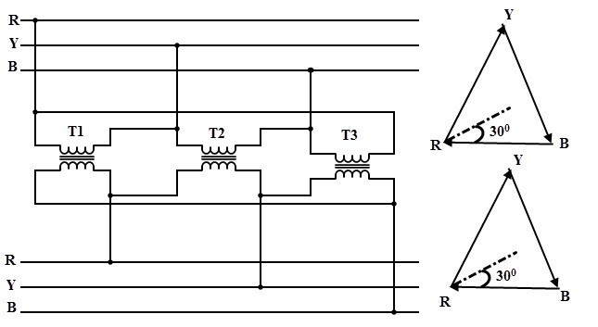

This type of connection is used when the supply source is delta connected and the secondary load needs single voltage with high current. This is generally employed for three phase power loads (like three phase motor).

In this, both primary and secondary windings are connected in delta fashion.
The voltage across the load is equal to the secondary voltage and voltage across the primary winding is equal to source voltage. In this, the current flow through the load will be 1.732 times the secondary current and the feeder current will equal to the 1.732 times current through the primary winding. Due to these high supply and load currents, it is recommended to place transformer much closer to both source and load circuits.

In this, there exists no phase difference between the primary and secondary voltages.

The three phase voltages remains constant even with unbalanced load, thus allows unbalanced loading.
The main advantage of this connection is if the one transformer is defective or removed for
service (open delta connection), then remaining two transformers continue to deliver thee phase power at reduced load capacity.

Star – Star Connection:-

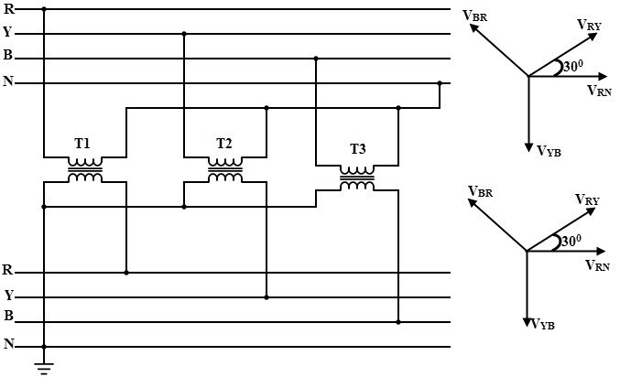

In this, both primary and secondary windings are connected in star fashion and also there exist no phase difference between the primary and secondary voltages.

In this, current flowing through both primary and secondary windings are equal to the currents of the lines to which they are connected (supply source and load). And voltages between line phases on either end equal to 1.732 times respective winding voltages.
Due to neutral availability, it is well suited for three phase four wire system.
This type connection satisfactorily works if the load is balanced. But if the load is unbalanced, the neutral point shift causes unequal phase voltages.
Large third harmonic voltages would appear in both primary and secondary windings
without the neutral tie. This may lead to the insulation failures.
This connection considerably generates interference with communication lines and hence with this connection configuration, telephone lines cannot be run in parallel.
Due to these disadvantages, the star-star connection is rarely used and not employed
in practice.
(4.3) Condition for parllal operation of transformer:-

Sometimes, it becomes necessary to connect more than one transformers in parallel, for example, for supplying excess load of the rating of existing transformer. If two or more transformers are connected to a same supply on the primary side and to a same load on the secondary side, then it is called as parallel operation of transformers.

Condition of Parallel Operation of Transformers

Increased Load:-
When load is increased and it exceeds the capacity of existing transformer, another transformer may be connected in parallel with the existing transformer to supply the increased load.

Non-availability of large transformer:-
If a large transformer is not available which can meet the total requirement of load, two or more small transformers can be connected in parallel to increase the capacity.

Increased reliability:-
If multiple transformers are running in parallel, and a fault occurs in one transformer, then the other parallel transformers still continue to serve the load. And the faulty transformer can be taken out for the maintenance.

Transportation is easier for small transformers: -

If installation site is located far away, then transportation of smaller units is easier and may be economical.
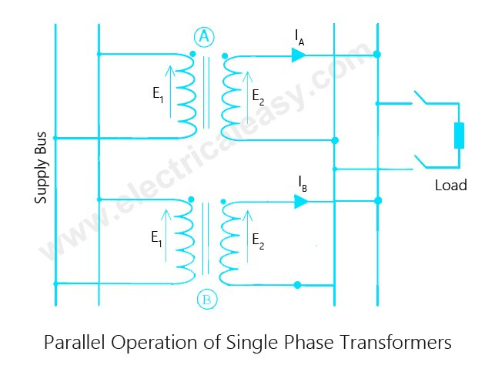

Conditions for Parallel Operation

When two or more transformers are to be operated in parallel, then certain conditions have to be met for proper operation.

These conditions are -

Voltage ratio of all connected transformers must be same.:-

If the voltage ratio is not same, then the secondaries will not show equal voltage even if the primaries are connected to same busbar. This results in a circulating current in secondaries, and hence there will be reflected circulating current on the primary side also. In this case, considerable amount of current is drawn by the transformers even without load.

The per unit impedance of each transformer on its own base must be same.:-

Sometimes, transformers of different ratings may be required to operate in parallel. For, proper load sharing, voltage drop across each machine must be same. That is, larger transformer has to draw equivalent large current. That is why per unit impedance of the connected transformers must be same.

The polarity of all connected transformers must be same :-
In order to avoid circulating currents in transformers. Polarity of a transformer means the instantaneous direction of induced emf in secondary. If polarity is opposite to each other, huge circulating current flows.
The phase sequence must be identical of all parallel transformers.:-

This condition is relevant to poly-phase transformers only. If the phase sequences are not same, then transformers can not be connected in parallel.

The short-circuit impedances should be approximately equal :-

(as it is very
difficult to achieve identical impedances practically).
(4.4)

On-load tap-changing transformer:-

In order that the supply may not be
interrupted, on-load tap changing transformer are sued. Such a transformer is known as a tap-changing under load transformer. While tapping, two essential conditions are to be fulfilled.

The load circuit should not be broken to avoid arcing and prevent the damage of contacts.
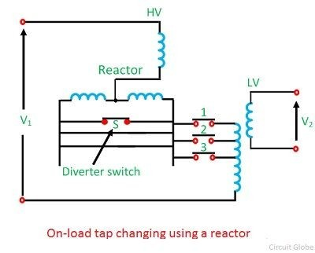 No parts of the windings should be short–circuited while adjusting the tap.

The tap changing employing a center tapped reactor R show in the figure above. Here S is the diverter switch, and 1, 2, 3 are selector switch. The transformer is in operation with switches 1 and S closed. To change to tap 2, switch S is opened, and 2 is closed. Switch 1 is then opened, and S closed to complete the tap change. It is to be noted that the diverter switch operates on load, and no current flows in the selector switches during tap changing.

It is to be noted that the diverter switch operates on load, and no current flows in the selector switches during tap changing. During the tap change, only half of the reactance which limits the current is connected in the circuit.
Difference Between Power
Transformer and Distribution Transformer

BASIS OF
DIFFERENCE POWER TRANSFORMER DISTRIBUTION TRANSFORMER

Type of network It is used in transmission network of higher voltages
It is used in the distribution network for lower voltages.
Availability of ratings
Maximum rating
400 kV, 200 kV, 110 kV , 66 kV, 33
kV. 11 Kv, 6.6 Kv, 3.3 Kv, 440 V,230 V
Power transformers are used for rating Distribution transformers are used for
of usage
Size
above 200 MVA
rating less than 200 MVA
Larger in size as compared of
distribution transformers Smaller in size
Designed
Efficiency
Designed for maximum efficiency of
100% Designed for 50-70% efficiency
Here All Day Efficiency is considered. It

Efficiency formula

Efficiency is measured as the ratio of output to the input power
is the ratio of output in kilowatt hour (kWh) or watt hour (Wh) to the input in kWh or Wh of a transformer over 24 hours.

Application Used in generating stations and transmission substations

Losses Copper and iron losses take place throughout the day
Load fluctuation In power transformer the load
Used in distribution stations, also for industrial and domestic purposes
Iron losses take place for 24 hours and copper losses are based on load cycle

Operating
fluctuations are very less Load fluctuations are very high
Operated at load less than full load as
condition Always operated at full load

load cycle fluctuates
Considering time It is independent of time It is time dependent
As compared to power transformer the
Flux density In power transformer flux density is higher

Designed to utilize the core for

flux density is lower in distribution transformer

Designing of the core
Usage
maximum and will operate near to the saturation point of the B-H curve,
As compared to power transformer the flux density is lower in distribution
which helps to bring down the mass of transformer
core
Used to step up and step down
voltages Used as an end user connectivity

Power Transformer-

The Power Transformer is installed at various power stations for generation and transmission of power. It acts as a step-up or a step-down transformer for increasing and decreasing of the level of voltages as per the requirement, and it’s also used as an interconnection between two power stations.

Distribution Transformer-

The Distribution Transformer is used to bring down or step down the voltage and current level of a transmission line to a predefined level, which is called safety level for the end user consumer in domestic and industrial purpose.

Difference Between Power Transformer and Distribution
Transformer-

Power transformers are used in transmission network of higher voltages whereas the
Distribution Transformers are used in the distribution network of lower voltages.
The power transformers are available in various ratings of 400 KV, 200 KV, 110 KV,
66 KV, 33 KV in the market and the distribution transformer are available in 11 KV,
6.6 KV, 3.3 KV, 440 V, 230 Volts.
The power transformer always operates on rated full load as the load fluctuation is very less but the distribution transformer is operated at the load less than full load as the variation in the loads are very high.
The power transformers are designed for maximum efficiency of 100%, and the
efficiency is simply calculated by the ratio of output power to the input power, whereas the distribution transformer the maximum efficiency varies between 50-70% and calculated by All Day Efficiency.
Power transformers are used in power generating stations and transmission
substations, and the distribution transformer is installed at the distribution stations from where the power is distributed for the industrial and domestic purposes.
The size of the power transformer is large as compared to the distribution
transformers.
In Power Transformer, the iron and copper losses take place throughout the day but in distribution transformer the iron loss takes place 24 hours i.e., throughout the day,
and the copper losses depend on the load cycle.
(4.6) Methods of cooling of transformer:-

No transformer is truly an 'ideal transformer' and hence each will incur some losses, most of which get converted into heat. If this heat is not dissipated properly, the excess temperature in transformer may cause serious problems like insulation failure. It is obvious that transformer needs a cooling system.

Transformers can be divided in two types as:-
(i) dry type transformers
(ii) oil immersed transformers.

Different cooling methods of transformers are -

For dry type transformers:-

1. Air Natural (AN)
2. Air Blast

For oil immersed tranformers:-

1. Oil Natural Air Natural
2. Oil Natural Air Forced
3. Oil Forced Air Forced
4. Oil Forced Water Forced

Cooling methods for Dry type Transformers

1. Air Natural or Self air cooled transformer

This method of transformer cooling is generally used in small transformers (upto 3 MVA). In this method the transformer is allowed to cool by natural air flow surrounding it.

2. Air Blast

For transformers rated more than 3 MVA, cooling by natural air method is inadequate. In this method, air is forced on the core and windings with the help of fans or blowers. The air supply must be filtered to prevent the accumulation of dust particles in ventilation ducts. This method can be used for transformers upto 15 MVA.
Cooling methods for Oil Immersed Transformers

1. Oil Natural Air Natural (ONAN)

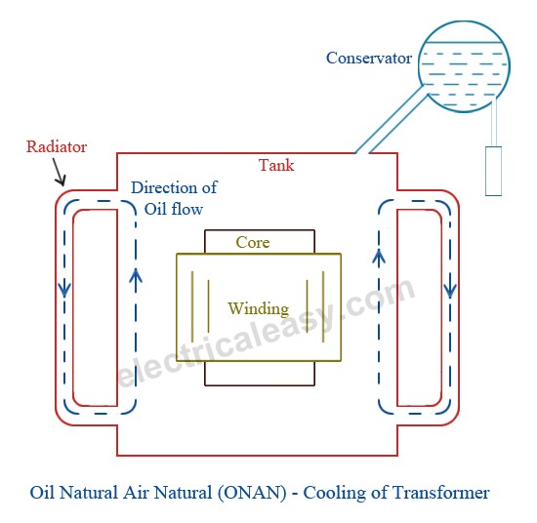
This method is used for oil immersed transformers. In this method, the heat generated in the core and winding is transferred to the oil. According to the principle of convection, the heated oil flows in the upward direction and then in the radiator. The vacant place is filled
up by cooled oil from the radiator. The heat from the oil will dissipate in the atmosphere due to the natural air flow around the transformer. In this way, the oil in transformer keeps circulating due to natural convection and dissipating heat in atmosphere due to natural conduction. This method can be used for transformers upto about 30 MVA.

2. Oil Natural Air Forced (ONAF)

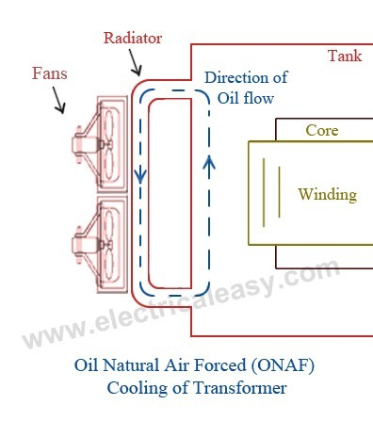
The heat dissipation can be improved further by applying forced air on the dissipating surface. Forced air provides faster heat dissipation than natural air flow. In this method, fans are mounted near the radiator and may be provided with an automatic starting arrangement, which turns on when temperature increases beyond certain value. This transformer cooling method is generally used for large transformers upto about 60 MVA.

3.Oil Forced Air Forced (OFAF)

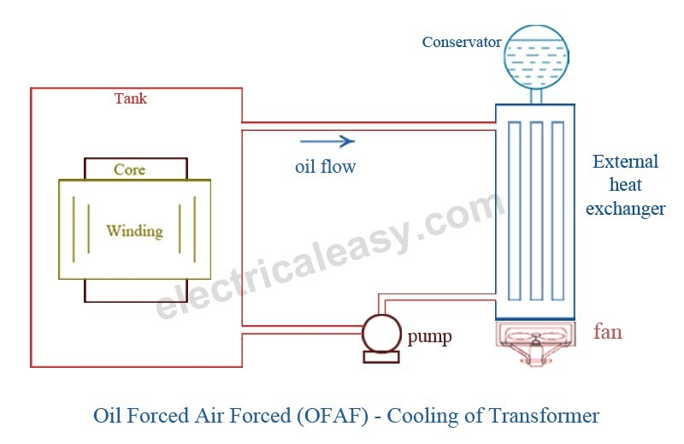

In this method, oil is circulated with the help of a pump. The oil circulation is forced through the heat exchangers. Then compressed air is forced to flow on the heat exchanger with the help of fans. The heat exchangers may be mounted separately from the transformer tank and connected through pipes at top and bottom as shown in the figure. This type of cooling is provided for higher rating transformers at substations or power stations.

4. Oil Forced Water Forced (OFWF)

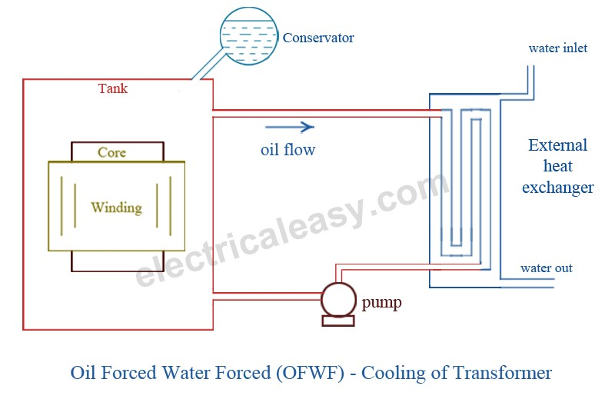
This method is similar to OFAF method, but here forced water flow is used to dissipate hear from the heat exchangers. The oil is forced to flow through the heat exchanger with the help of a pump, where the heat is dissipated in the water which is also forced to flow. The heated water is taken away to cool in separate coolers. This type of cooling is used in very large transformers having rating of several hundreds MVA.

